# Remove a friend

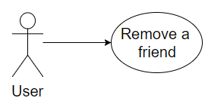

## Characteristic Information

|  |  |
| --- | --- |
| Superior business process: | The user opens the “friendlist” view |
| Goal: | Remove a friend from his friendlist |
| Precondition: | A user wants to get a friend out of his friendlist |
| Postcondition: | You reworked your friend list in form of removing friends |
| Involved User: | The user of the chat-client |
| Triggering Event: | The user wants to get a friend out of his friendlist |

## GUI to call the use case

| Input field | Valid inputs |
| --- | --- |
| MessageTextBox | As in interact with friends |

## GUIs for the standard use

| Step | User | Activity |
| --- | --- | --- |
| 1 | User | Log in |
| 2 | User | Select friend |
| 3 | User | Press remove button |
| 4 | User | Press the „YES“ button |

## Scenarios for non-standard uses (bad cases or work around cases)

## GUIs for the non-standard uses

## Workflow

## Open Points